Parent Help NEEDED!
Please help us clean our kinder chairs!

Our TK /Kinder chairs are super dirty
and our students deserve better!

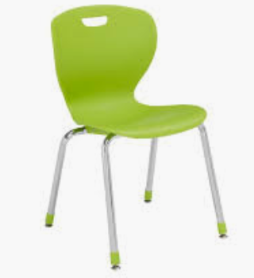

Please come help us by scrubbing a few chairs during our

Parent Information Meeting

Thursday 10/17, starting at 8:30!

Coffee and snacks provided,
and we will also hold a raffle for a
$20 Target gift card!
PARENT HELP NEEDED!
Please help us clean our kinder chairs!

Our TK /Kinder chairs are super dirty and our students deserve better!

Please come help us by scrubbing a few chairs during our

Parent Information Meeting

Thursday 10/17, starting at 8:30!

Coffee and snacks provided,
and we will also hold a raffle for a
$20 Target gift card!

